**GEDA 500 Z/ZP Hoist Type C.**

Available for 30m lifting height, 10 x landing platforms, Platform Type C



|  |  |
| --- | --- |
| **Cargo** | Personnel and material |
| **Mast system** | GEDA UNI - MAST |
| **Load Capacity (material)** | 850kg |
| **Load capacity (persons)** | 5 persons / 500 kg |
| **Lifting Height** | 100m (max) |
| **Lifting Speed** | 12m/min / 24m/min |
| **Power supply** | 3 kW / 6.1kW / 400 V / 50 Hz / 16A |
| **Platform dimensions** | 1.4m x 1.6m x 1.1m/1.8m |

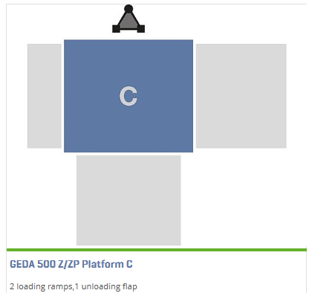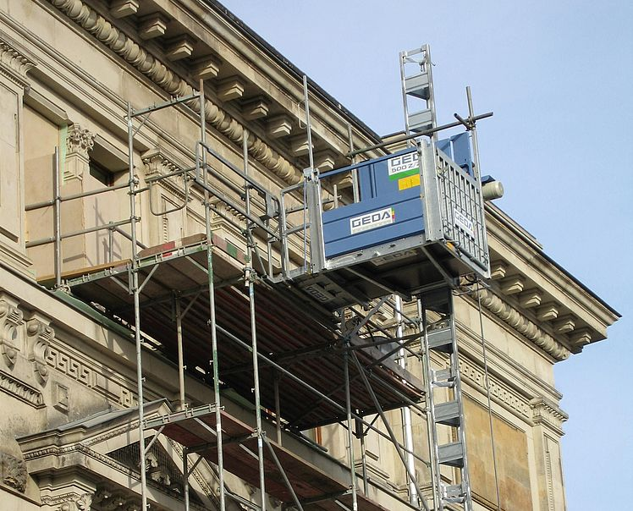**Technical Data**