**GEDA 1500 Z/ZP Hoist Type GD.**

Available for 30m lifting height, 10 x landing platforms, Platform GD & roof

|  |  |  |
| --- | --- | --- |
| **Description** | **No. Units** | **Total Weight** |
|  |  |  |
| GEDA 1500ZZP Diagnostic system (45573) | 1 | 2.5 |
| GEDA 500ZZP Steel mast 1.5m (1150) | 40 | 1760 |
| GEDA Trailing cable guide (1165) | 5 | 13.5 |
| GEDA Extension cord 20m (2513) | 1 | 4.4 |
| GEDA 1500ZZP base unit (2606) | 1 | 970 |
| GEDA Limit switch for 300/500/1500 Z/ZP landing level (2628) | 9 | 29.7 |
| GEDA cable bin with trailing cable 50m (1231) | 1 | 90 |
| GEDA 1500ZZP set of mast ties x2 for wall fixing ( 1239) | 4 | 240 |
| GEDA double landing level safety gate (1213) | 10 | 940 |
| GEDA 1500ZZP Platform GD with dbl ramp 1500/2000kg (2619) | 1 | 870 |
| GEDA Assembly plank (2626) | 2 | 80 |
| GEDA 1500ZZP roof 3 pcs for GD platform (17244) | 1 | 0 |
| GEDA 1500ZZP electric set (1211) | 10 | 0 |

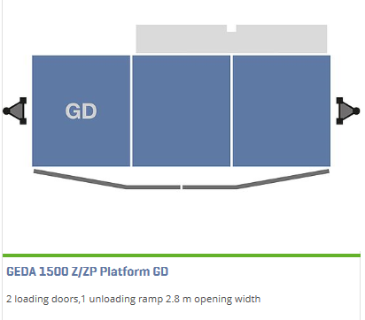**Technical Data**

|  |  |
| --- | --- |
| **Cargo** | Personnel and material |
| **Mast system** | GEDA UNI-MAST |
| **Load Capacity (material)** | 2000kg |
| **Load capacity (persons)** | 7 persons |
| **Lifting Height** | 100m (max) |
| **Lifting Speed** | 12m/min / 24m/min |
| **Power supply** | 2 x 3 kW / 6.1kW / 400 V / 50 Hz / 32A |
| **Platform dimensions** | 4.35m x 1.65m x 1.1m/1.8m |

